**Process for As-Builting Liquids Lines**

*\*\*\*You will need to turn in a weekly report on all work completed\*\*\**

* Records and documents for as-builting:
  + IMU/ILI/Survey Data: IMU or survey data is accurate to sub-meter GPS and should be used to correct the centerline. Do not adjust to ILI unless you are SURE it is sub-meter accurate. ILI can be used to check lengths of pipe, wall thickness, long seam, and presence of fittings.
  + Historic Construction Documents: Historic documents pertaining to original construction of the line
  + Alignment Sheets: These are historic alignments, which will be used to enter any missing data in the database
  + Maintenance Records (MRs): Maintenance which has been performed on the line (Foreign Line Crossings and Pipe Repairs)—these need to be both installed, and checked for presence in the database
  + Accompanying materials: Hydro tests (Splint Hydro records), Mill Test Reports, ILIs, Engineering drawings, Line Histories, GForms, Assessable Segments list, etc.
  + Field Note Guidelines: Instructions for correcting existing Field Notes (**See separate Word Document**)
  + Pipe Crossing Guidelines: Instructions for correcting existing Pipe Crossings as well as installing new Pipe Crossings from MRs (**See separate Word Document**)
* You will be installing and changing several things when as-builting, including:
  + **Pipe records** (Spec, Grade, Coating, Manufacturer, Installation date, Longitudinal Seam Type, etc.)
    - You may need to split existing pipe by weld, pipe manufacturer, or coating (for sleeves). Make as few pipe segments as possible while still retaining that information (i.e. if you have two pipe segments next to each other with the same Manufacturer, Grade, Coating, Wall Thickness, and Installation date, the segments don’t have to be split at the weld, and can be merged).
    - When doing a replacement, you will not break the pipe for the transition coating change at the start and end of the replacement; add it as a comment in the replaced pipe records (i.e. “3ft of tape coat extends past replacement”). **The old pipe record must be copied into Pipes_Arch and commented as “Removed per MR XXX”.**
    - NOTE: Any ERW pipe with an installation date before 1980 will be entered as ERW-LF. Post-1980 ERW pipe is ERW-HF, unless otherwise stated.
  + **Fittings** (Elbows, Flanges, Tees, and Reducers). The pipe **WILL** be split at the fitting, so take that into account when you calculate stationing. See examples on Page 13.
    - **Non-Controllable Fittings** should be installed with the following format in the Comments field:
      * For Flanges: “CL” followed by the size of the flange, type of flange, and then fitting type. In the example below, this is a 12” Raised Face Weld Neck Flange. If the type of flange is unknown, simply use “CL 12” Flange”.

|  |
| --- |
| CL 12” RFWN Flange |

* + - * For Elbows: “CL” followed by the size of the elbow, fitting type, the degree bend followed by ^, and the direction of the bend. Use LT, RT, UP, DN. Make sure these are fittings and not field bends.

|  |
| --- |
| CL 12” 3-R ELL 45^ LT |

* + - * For Reducers: CL followed by the sizes (there should be TWO), and then the fitting type.

|  |
| --- |
| CL 12”x10” Conc. Reducer |

* + - * For Tees: CL followed by the sizes (if it reduces), fitting type, and then the direction.

|  |
| --- |
| CL 12”x10” Reducing Tee Left |

* + - * **REMEMBER:** ANYTHING YOU WRITE IN COMMENTS WILL SHOW UP ON THE ALIGNMENT SHEET! Make it as short and easily understandable as possible.
  + **Pipe Crossings**. See the Pipe Crossing Guidelines Word document for information on installing and correcting these.
  + **Field Notes**. See the Field Note Guidelines Word document for information on correcting these. ***See this document for adding equations***
  + **Valves**. The pipe will be split at all the Mainline Valves, and the Pressure System changes at each MLV. If you come across multiple Valves in one location (either stacked or next to each other on the Mainline), and the valves do not specify what is MLV and what is Bypass, ask your Team Lead what should be done. ***If you move a Valve, make sure you use the Shorten/Lengthen Pressure System tool on the Toolbar***
    - **The Pressure System on the Valves will ALWAYS be the Ahead Pressure System**. Make sure you check each of your valves to ensure that the Pressure System matches the Pressure System on the pipe that immediately follows.
  + **Pressure systems**. Pressure Systems must be unique after each MLV and Station Equation. They should be named according to the upstream mainline valve number and have a lowercase letter starting with “a” (i.e. MLV-1402 = downstream valve section 1402a). If there is an equation, a new pressure system is installed at the equation and the Pressure System Name downstream of the equation is 1402b; if multiple equations exist between valve sections, the Pressure System Name will remain 1402 with the letter changing to the next in series (see diagram below).

PS =1402a

PS =1402b

PS =1402c

1402

PS=1403a

1404

1403

EQ

EQ

* + **Sleeves** (in the database under UPDM.Sleeve). These are versioned and DO need to be installed according to the MR. Fill in the attributes as best as you can from the details on the MR. Many of the repairs done are Clock Springs, which are considered Sleeves.
  + **Casings** (in the database under UPDM.PipeCasing). These are versioned and DO need to be installed according to the MR or historic document. They are usually installed under roads and railroad tracks on older lines. Fill in the attributes as best as you can from the details on the MR or historic document. Ask your Team Lead if you have questions.
  + **Welds** (in the database under UPDM.WELD). These are non-versioned, and DO need to be installed according to the MR. They are installed any time a pipe is replaced. ***Do not attempt to go back through the MRs and add historic welds or add them from alignment sheets. Only install Welds as you add MRs.*** Below is a sample of fields that need to be filled in as well as the format which each field should take:



* + - XRAYNUMBER is the weld number on MRs.
    - HEATNUMBER is the heat number of the Ahead pipe segment or fitting.
    - WORKORDERID is the Tracking ID of the MR or GForm #.
  + **Pressure Verification**. Many of these lines have Hydro Test records, but the Pressure Verification has not been installed in the database. When installing, ensure that **both** the **vertices** **and** the **attribute table** have been filled in correctly. A new Pressure Verification must be installed for each pipe replacement. NOTE: You will not be able to search for the Pressure Verification in the database using related tables; you will have to query by RouteID to see any Hydros for that line. Splint hydro records need to be searched for each line using the Master List (Splint_HydroTest_ProductionData), and any found Hydros added to the database.
    - If adding a new Hydrotest for an entire line (there is not an existing hydrotest for the line), follow these steps to quickly import a hydro for the line:
      * Make sure you have a definition query on Pipes for your line only, you are NOT editing, and nothing is selected in your map
      * Right click the Pipes layer in the Table of Contents
      * Select **Data** > **Export Data** > **All Features** > **This Layer’s Source Data** > Click the folder icon to save your shapefile
      * When prompted to add the layer to your map, select **Yes**
      * Start editing the shapefile you added
      * Right click the shapefile and click **Selection** > **Select All**
      * In the Editor toolbar, select **Merge** and be sure that “Preserve Overlapping Segments” is **NOT** selected
      * Stop editing and save edits
      * Be sure that your Pressure Verification layer is turned on
      * Start editing your version
      * Right click the shapefile you edited and click **Selection** > **Select All**
      * Right click the map and click **Copy** > **Paste**
      * When prompted for the layer, select Pressure Verification
      * Fill in all of the missing attributes for the hydrotest
    - **Pressure Test** is the test record number—this can ONLY be a numerical value!
    - **Min Design Pressure** is the targeted minimum test pressure
    - **Min Adjusted Pressure** is the actual minimum test pressure
    - **Unit of Measure** will always be PSIG or psi
    - **Test Type** will be Strength
    - **TVC Material Verified** will always be YES if you have the hydrotest record
    - **TVC Date Verified** is the date that you verified the record
    - **TVC Comments** will be any relevant information listed on the record about the test (from station to station, line size, was this the result of a line failure, etc.)
    - If adding a hydrotest for a pipe replacement, you must add the hydrotest manually. Make sure that you have filled out **BOTH** your **vertices** and **attribute table** with the correct measures.
    - Hydrotests can span multiple Pressure Systems, but they CANNOT span multiple Systems. You need a new hydrotest for each System record.
  + **MAOP/MOP**. Unless a new MOP has been established by the Integrity group, **ONLY** correct the geometry of the existing MOP centerline. If you have an MOP document, you may install a missing MOP.
    - If you are installing a new MOP for an entire line, you may follow the same directions as above to import the line to the MAOPMOP layer
      * Make sure you have your MAOPMOP layer turned on
      * You can use the same shapefile for your hydrotest line to import the MOP line
      * Make sure you have filled out **BOTH** your **vertices** and **attribute table** with the correct measures.
    - **Pressure Type** will almost always be **Strength Test**
    - **Date Determined** is the date on the hydrotest or MOP document
    - **Verified By** is the person who signed off on the MOP document
    - **Comments** will be any relevant information about the MOP determination
    - **Det Factor Methodology** is the Determining Factor Methodology. This will usually be 195.406.
    - Fill out any other relevant data in the table
    - MOPs can span multiple Pressure Systems, but they CANNOT span multiple Systems. You need a new MOP for each System record.

NOTE: When searching the System table for the correct line, make sure you select the correct line. Sometimes there is more than one record for the System. In the example below, the second record is Abandoned Pipe.



**Do not assume anything on these records! There is no default coating, pipe spec, or grade!**

**The order of operations for your work should be:**

1. Update Piggable/Assessable Segments (THIS STEP SHOULD HAVE ALREADY BEEN COMPLETED FOR ALL LINES)
   * If the line has more than one launcher or receiver valve, you must update the Piggable Segments in the System table. See the SXLAssessableSegmentList Excel file to update SXL Lines
     + To create a new Piggable segment, you should create a new System using the System Split tool and update with the data from the existing System. Check the SXLAssessableSegmentList spreadsheet to determine what to name your segments. ONLY USE THE BOLT TOOLBAR TO CREATE NEW SYSTEMS!!!
       - Your Proper Name will change to the line number followed by a period and a two-digit number (*i.e.* 12124.01, 12124.02, etc.)
       - Your SYSTEMNAME will change to the line number followed by a period and a two-digit number, and the name of the Piggable Segment (*i.e.* 12124.01 – Montello-Mt. Union)
     + Example: The Piggable Segments for the line below would be **12124.01** – Montello-Mt. Union, **12124.02** – Mt. Union-Altoona, **12124.03** – Altoona-Delmont. This example has 3 Piggable Segments because there is a launcher/receiver at each of these Pump Stations ***NOTE: If your line has only one launcher and receiver, NOTHING needs to be done with Systems***

Montello

Delmont

Altoona

Mt. Union

1. Adjust the line according to the survey data or IMU
   * You will need to import the survey data or IMU from the Excel spreadsheet provided. Each file contains lat/long data that will appear as points and will aid you in adjusting the line. It may help to run the *Points To Line* tool in ArcToolbox which connects the survey or IMU points into a line to adjust the centerline. Ask your Team Lead if you have questions.
   * The survey/ILI has features listed—pay close attention to those when moving the line. The survey may be calling out a fence, property line, PI, or water crossing. These may already exist as Field Notes or Crossings, which can help in determining where the line moves. The major features you will want to snap the line to are: Welds, AGMs, Fittings, Casings, Sleeves, Taps, and Valves.
   * Make sure to check for other features when you move the line, as they may have stayed behind (Casings, Sleeves)
2. Check Casings, Sleeves, Field Notes, and Pipe Crossings

* Are Casings and Sleeves installed at the correct stationing on the line? If not, move them to the correct stationing. Is the diameter, type, material, install date, crossing type, and wall thickness filled in for casings?
  + REMEMBER: Casings WILL NOT be installed around bends. If you find a Casing that covers a bend, move it so that it is on a straight section of pipe.
* Are Field Notes and Crossings in the correct format on the entire line? Has all information been filled in? CHECK the Process Document for Field Notes and Crossings if you are unsure.
* Inactivate Field Notes if they meet these criteria:
  + Duplicate field notes (EXCLUDING PIs on EQUATIONS)
  + Hazards and Trench Breakers
  + PIs with angles under 5°
  + Notes relating to replacements (i.e. “begin/end replacement”)—DO NOT confuse these with “begin/end relocation”, which are needed

1. View and enter historic document information in database (PigData), and add missing data from historic alignment sheets
   * Work from most current backwards to oldest
   * Documents will mostly consist of pipe data, coating, installation year, in-service date, and hydro information
   * Check Adept for other historic documents (e.g. relocation drawings, SunMap and original alignment sheets)
   * Crossings, Sleeves, Casings, Field Notes, Fittings, and Valves are usually displayed on old alignments; install anything you notice is missing including test stations, rectifiers, and magnets
     + Some road names have changed since historic alignments were generated. Check the name against Google to be sure you have the most current road name; enter the old road name from the alignment sheets in the Comments field, and the new one in Remarks
   * Install any missing coatings, pipe data, replacements, re-routes, and equations (Re-routes and replacements **must be verified** with supporting documents such as MRs or drawings).
2. Install Maintenance Records
   * Look in all three drive locations for MRs: Maintenance_Records>Historic, Maintenance_Records>Pipeline, and MR_Processing>03_MR_GIS_Inbox. Also look in the ETIH drive for any records that were scanned in by Erin (\ETIH\Apps\caddata\asbuilt\PA Icedale Eng Records\Erin) and Jennifer (\ETIH\Apps\caddata\asbuilt\PA Icedale Eng Records\Jennifer).

* Check the database for each record. If you don’t see it, it needs to be installed. ***Make sure to check the lat/long AND the stationing—sometimes the lat/long does not match stationing or is not near the line***
* Instructions for completing Pipe replacement MRs are below. See Pipe Crossing Guidelines Word Document for installing Foreign Line Crossings.
* For records that have already been “completed”, there are three designations at the end of the file name: **V**, **F**, and **R**. **V** is for **Visual Inspection**, and nothing needs to be installed for the record, but other information can be verified (such as coating information). **F** is for **Foreign Line Crossing**, and it means that a Pipe Crossing needs to be installed. **R** is for **Repair**, and it means that a Pipe has been repaired or replaced and needs to be installed. Check each record to verify it is in the database regardless of “completed” status.
* Check **GForms** for Pipeline Inspections, Foreign Line Crossings, or Repairs that have been performed on the line. These may have been completed in GForms and we may not have copies of the repairs in MR form.
  + Navigate to Project Pulse > GForms.
  + Under Document Hierarchy, fill in the first four fields to get Discharge to populate.

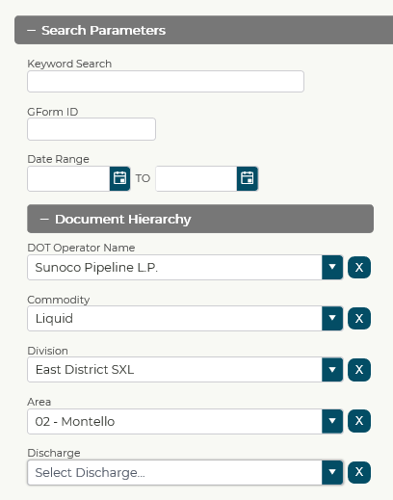

* Click on each GForm to view it. Install GForms that are not in the database. You will be looking for Valve Maintenance Reports, Pipeline Inspections, and Foreign Line Crossings. **\*\*\*You will not install new Foreign Line Crossings from GForms! You will only check the ones that have already been installed\*\*\***

1. Update/fix Valve Sections
   * Use the Bolt toolbar to update, split, and sync the Pressure Systems
     + **Pressure Systems need to be split at Valves and Equations.**
     + Review the Appendix to the UPDM As-Built Procedures Manual discussing the new Bolt Toolbar
   * This may also entail removing valves from the mainline and moving them to new Detail Pipe. Use imagery, the Comments field in the Valve table, and the Valve diameters to determine which Valves belong on the mainline and which belong on Detail Pipe. ***Don’t be afraid to email or call someone from the area to ask them to verify!!!*** Mark any Mainline Valves as “Isolation” under Valve Use.
   * See example on Page 2 above for how Pressure Systems should be split
   * **If you come across a Pressure System that is not associated to any Pipes or Archived Pipes, put “_Not_Used” at the end of the existing Pressure System Name, and in the Pressure System COMMENT_TEXT field, add a comment to the existing field saying “Not used – (Month & Year)”.**
   * **If the Pressure System ONLY has Archived Pipes associated with it, change the Pressure System Name to “0a_Archive”, and in the Pressure System COMMENT_TEXT field add a comment to the existing field saying “Archived – (Month & Year)”. BE VERY CAREFUL to check the OPERDIVISION field and make sure it doesn’t say 04-Archive, 08-Historic, or 09-Abandoned. IF YOU CHANGE THESE RECORDS, YOU WILL NOT BE ABLE TO REC & POST!**
2. Hydro correction/installation and MAOP correction
   * Add new Hydros from pipe replacements, verify historic Hydros are installed, and check for MAOP
3. Check the As-built List spreadsheet (Transmission Tracker tab, second-to-last column) for comments from contractors
   * Review the comments and make sure that any issues found by the contractors have been resolved in your QC of the line. If so, change the fill color of the cell to No Fill.
4. Regenerate alignment sheets
   * Remember: there is an overnight delay on HelloSheets for versioned features. If you post today, your changes will not show up on alignments until tomorrow (unless ONLY editing non-versioned features).
5. Notify Team Lead that alignments for your line are ready for Field Ops and Integrity group to review
   * Track date completed on As-built List spreadsheet in Metrics tab and Transmission Tracker tab
   * Track date completed on Line Assignment Tracker spreadsheet (Transmission Metrics tab) and record the hours worked on line as well as any issues you had with completion

***If working on a Deferred or Idle line, please check the system table and make sure that the Pipe Status and Product Type are correct!!

* If Pipe status says IDLE, it needs to be changed to Deferred. **IDLE is not a valid status and should NOT be used.**
* If Product Type is Nitrogen, the Product Type and Product Group need to be changed to reflect what was in the pipe before it was Deferred. **If you have a line deactivation GForm, DO NOT change the Product Type to Nitrogen!**

Below is a two-page example of an MR which has already been completed, and how these inputs appear in the database.

BLUE BOX: The SCADA name and Line number you’re working on

RED BOXES: The lat/longs you will use to find your work area in the database; if no lat/long is provided on the MR, you can use the Linear Referencing tool to locate your work area. If you need assistance, ask your Team Lead.

YELLOW BOXES: The comments you will use to fill out the COMMENTS field for Pipes and Welds in the database

PURPLE BOX: The Record Tracking ID number you will use in place of WorkOrderID in the database

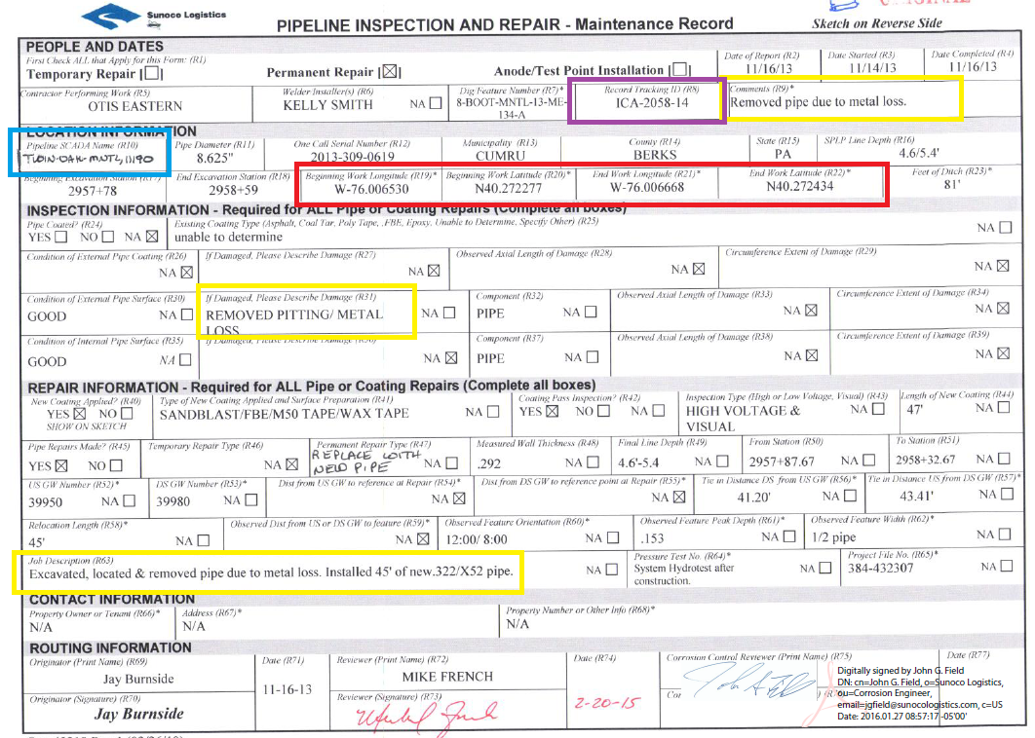

GREEN BOXES: Information you will enter in the database for Pipe records

ORANGE BOXES: Information you will enter in the database for Weld records and for Heat number on Pipe records

GREY BOXES: Information you will use to ensure your MR is installed in the correct location with the correct length

PURPLE BOX: The same Record Tracking ID number from the first page

BLACK BOXES: Weld X-Ray numbers

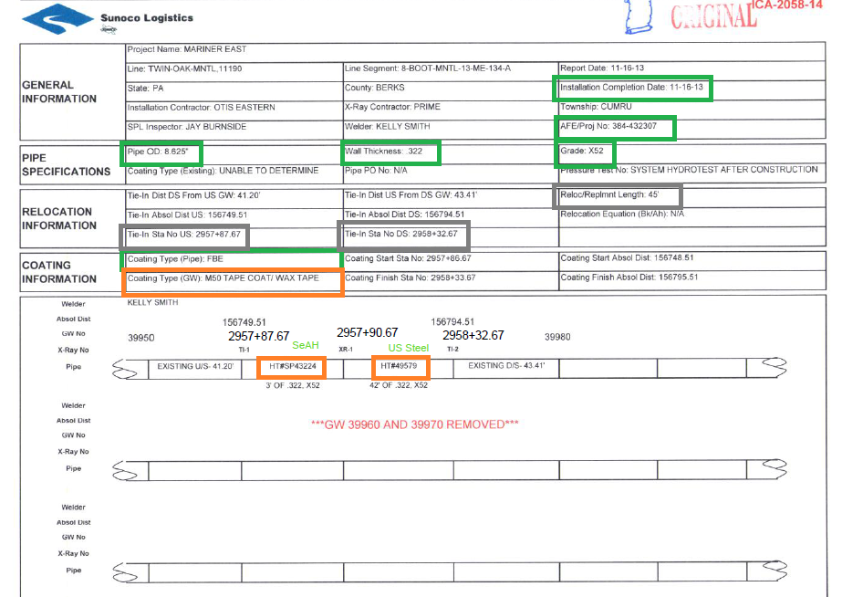

* Notice that this MR has two different heat numbers on it and has already been labeled with the Pipe manufacturers. Your MRs will not be labeled with Manufacturer information.
* The tie-in stationing from the grey boxes has also been filled in on the diagram. These may not appear on all of your MRs, but it is your responsibility to **CHECK** the stationing on the diagram—it might not always be correct!!

Below is how this MR should appear in the database.

BLUE BOXES: Use your Go To XY Tool to find your lat/long.

GREEN BOX: There are TWO pipe records here, as per the MR. All of the information from the second page of the MR has been filled in.

BLACK BOXES: There are THREE welds here, as per the MR. All of the information from the first and second pages of the MR has been filled in.

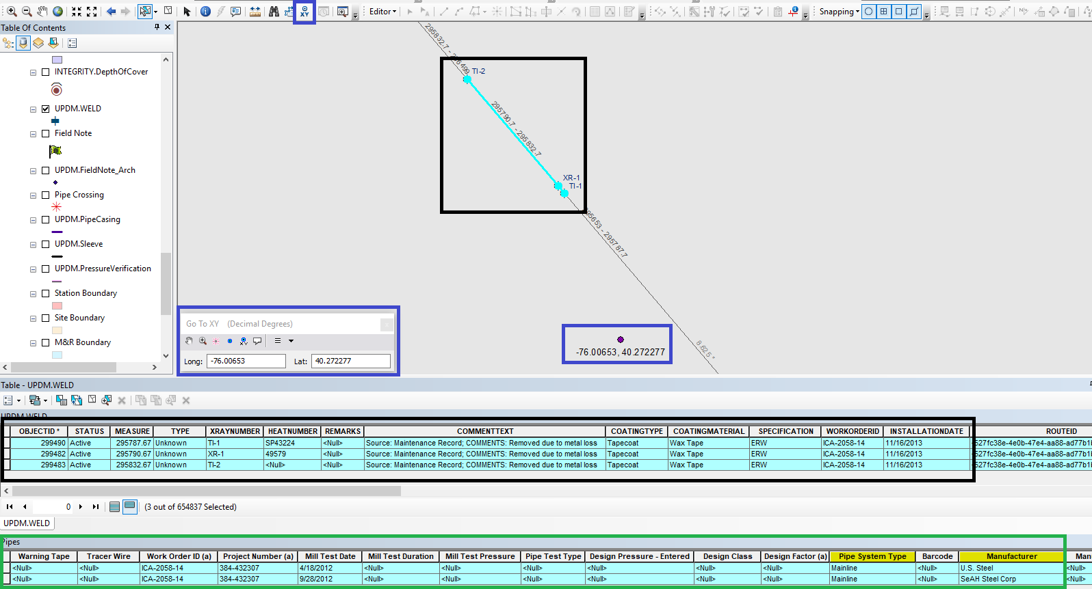

Below is a more complicated example of a MR, where the pipe is split by Fittings as well as Welds and Pipe Manufacturer.

GREY BOXES, STATIONING AND LINES: Where the pipe will be split due to the Fitting. Since Fittings are point files, everything up to the grey line will be the Pipe Manufacturer before the line.

GREEN LINES AND ARROWS: Where the pipe will be split due to Pipe Manufacturer change.

BLACK BOXES: Weld X-ray numbers. Notice that this is also where the pipe is split when there is a Pipe Manufacturer change.

RED CIRCLES: Heat numbers for Pipe and Fittings.

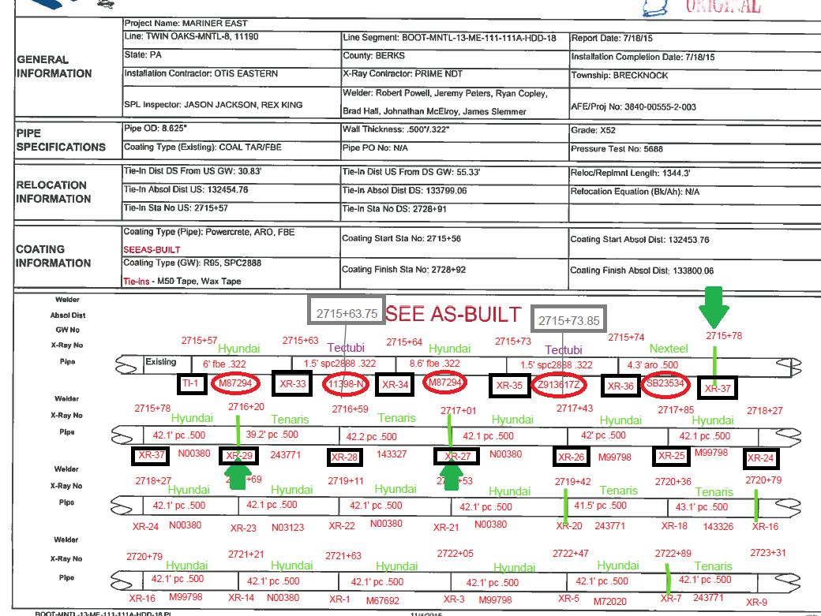

**Note**: There are instances on this MR where the heat number changes, but the Pipe Manufacturer does not change. If all of the information for the Pipe is the same except for the Mill Test date, you can still merge the Pipe records in the database. Choose the OLDEST Mill Test date from all of the MTRs and use that.

Fitting example: The first fitting is an ELL (Tectubi) at station 2715+63.75. The Hyundai Pipe is 6’ long between Welds TI-1 and XR-33. The Tectubi ELL is 1.5’ long between Welds XR-33 and XR-34. Since the Pipe is split at the fitting, your Tectubi ELL length is split in half to account for the Fitting point (1.5’/2=0.75’). So, the stationing for the Hyundai Pipe will extend from station 2715+57 to station 2715+63.75 where the first Tectubi ELL is (2715+57 + 6’ = 2715+63 and 2715+63 + 0.75’ = 2715+63.75).

Pipe and weld example: The first time the Pipe is split by Manufacturer is at Weld XR-37 (station 2715+78.9), when the Pipe transitions from Nexteel to Hyundai. ***THE STATIONING ON THIS DIAGRAM IS NOT ACCURATE—ALWAYS CHECK!!*** The Nexteel Pipe begins at station 2715+73.85 with the Tectubi Fitting and extends to station 2715+78.9 at Weld XR-37. The Hyundai Pipe begins at the same Weld (XR-37), and extends to station 2716+21 at Weld XR-29.

This example appears in the database as below.

GREEN ARROWS: Pipe split due to Manufacturer Change at Welds.

GREY ARROW: Pipe split due to Fitting (ELL).

